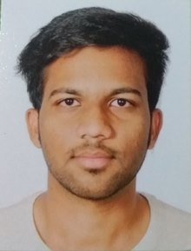
Name: Ms. Pooja Deepak Dalvi Name: Mr. Shubham Rajendra Koli
Branch: - Industrial Engineering Branch: - Instrumentation and Control Engg.
Current Year: - Third Year B. Tech. Current Year: - Third Year B. Tech.

Name: Mr. Devang Devesh Abyhankar
Branch: - Mechanical Engineering
Current Year: - Third Year B. Tech.

Ms. Pooja Deepak Dalvi, Mr. Shubham Rajendra Koli & Mr. Devang Devesh Abyhankar have been selected for Students Exchange Program at Hof University of Applied Sciences, Germany for the Academic Year 2016-17 (Sem – II).
Heartiest congratulations to them for receiving the scholarship amounting of EUR 4820 in total (per student) under Students Exchange Program of Hof University of Applied Sciences, Germany.
Hof University of Applied Sciences, Germany has signed a MoU with Vishwakarma Institute of Technology, Pune regarding Erasmus + Program.
The scholarship has been granted under the Erasmus + Programme which is funded by European Union and the main aim is the advancement of the mobility of university members. Till 2014 Erasmus was concentrated to European Countries. Since 2015 the programme was opened for further countries. Thus Hof University got the possibility to cooperate with selected universities in India.
Heartiest congratulations to the students for achieving this goal.
The institute is proud of this achievement and wishes them all the best for future career.

