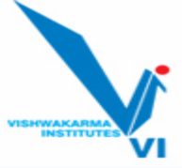 **Vishwakarma Institute of Technology, Pune - 37**

**(An Autonomous Institute Affiliated to Savitribai Phule Pune University)**

**Department of Multidisciplinary Engineering**

**EDI (Sem II 2024-25) INNOVATION EXPO-2025**

**INNOVATION EXPO-2025-1 EDI Project Exhibition Report**

**Date: 31st January 2025**

We at Vishwakarma Institute of Technology, Pune, are committed to fostering innovation and creativity among its students. EDI practice hands-on experiments. This is an invaluable educational tool. It offers benefits such as increased engagement, improved understanding, active learning and the development of critical life skills. The Department of Multidisciplinary Engineering organized a project exhibition **INNOVATION EXPO-2025** on Friday 31st January 2025, 1:00 pm to 3:00 pm. 30 best projects were selected, one from each batch,3 from each division, during the end semester examination, Semester 1, Academic Year 2024-25. The aim of the exhibition was to emphasis the importance of multidisciplinary projects in second year and also to encourage other students to identify innovative problem statement , get motivated to work on their EDI projects.

**Inauguration Ceremony**

The Inaugural Ceremony of **INNOVATION EXPO-2025** was hosted by Prof. Dr. Shilpa Lambor, Head of Department of Multidisciplinary Engineering. The ceremony started with a warm welcome to the chief guest. Dr. Kailash Shaw, Prof. Swati Joshi Madam, Prof. Dr. Pramod Kanjalkar, Prof. Dr. Manik Deosarkar, Prof. (Dr.) Sangita Jaybhaye,Prof. Dr. Gopal Upadhye, Prof. Archana Chaudhari, Prof. (Dr.) Vaishali Jabade, Prof. (Dr.) Ganesh Bhutkar, Prof. Kalpesh Joshi, Prof. Girish Kotwal, Prof. Gajanan Gambhire, Prof. Dr. Avadhoot Rajurkar, Prof. Prakash Vaidya were the revered judges for the EDI Innovation Expo-2025.

**Event Details**

The inauguration ceremony was followed by the project exhibition **INNOVATION EXPO-2025**. All the participating teams were highly motivated to showcase their design skills and projects.

The project groups were allotted a venue (Labs 1201,1202, 1207, 1209 and 1223) according to their branch. CR ACR student representatives was appointed for every venue to have smooth functioning of interaction between the judges and the project teams. The judges highlighted certain pros and cons of each respective project and gave suggestions for further enhancements. The evaluating judges were quite impressed by the innovative ideas and efforts put by the students to implement their ideas. Students were guided regarding how they can deploy their innovative projects and ideas in the actual market. Few project groups had amazing concepts implemented which impressed the judges and they suggested to continue with the projects in ensuing semesters.

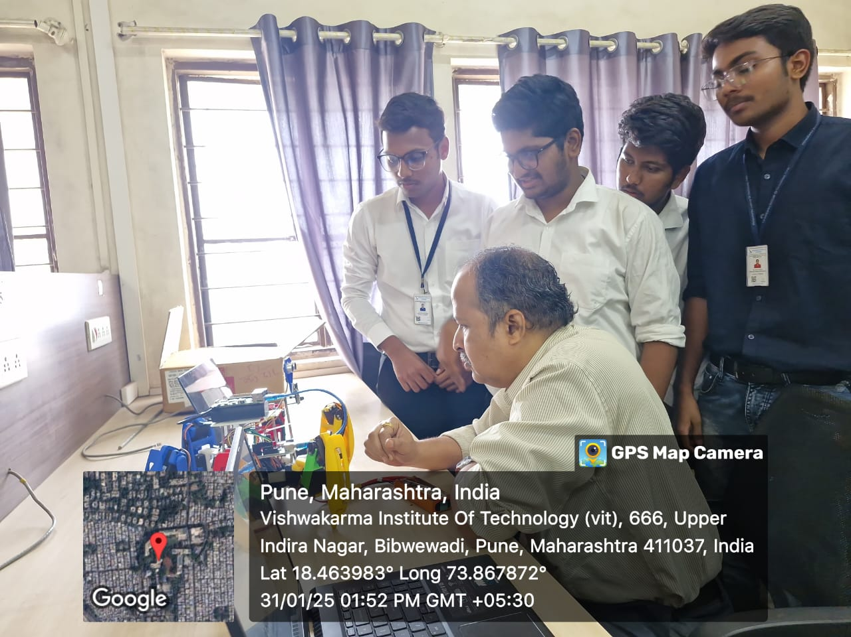**Glimpses of the Event**

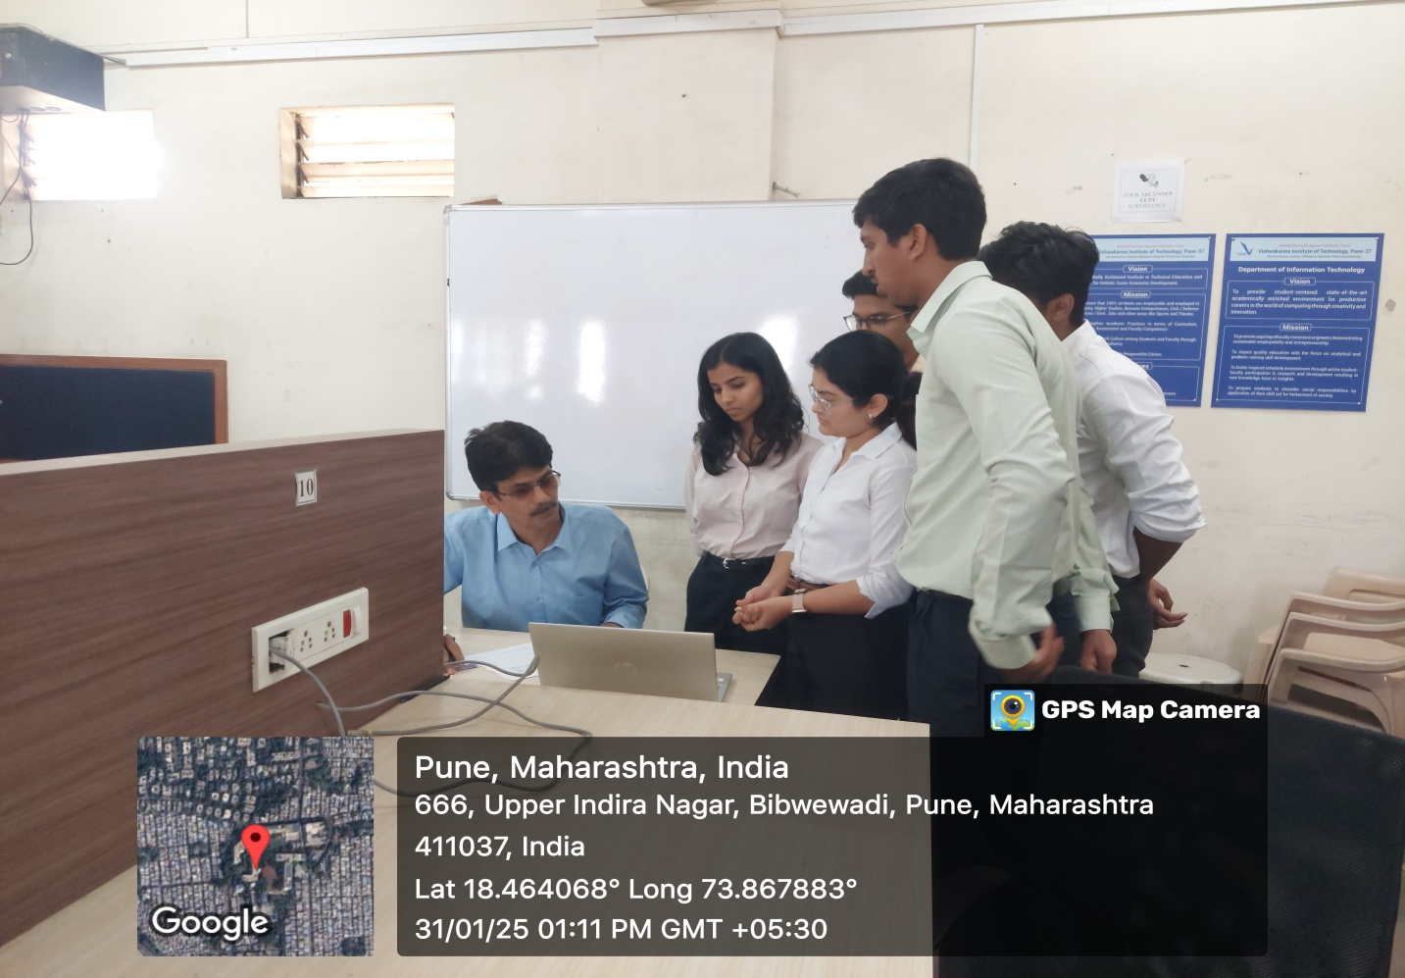

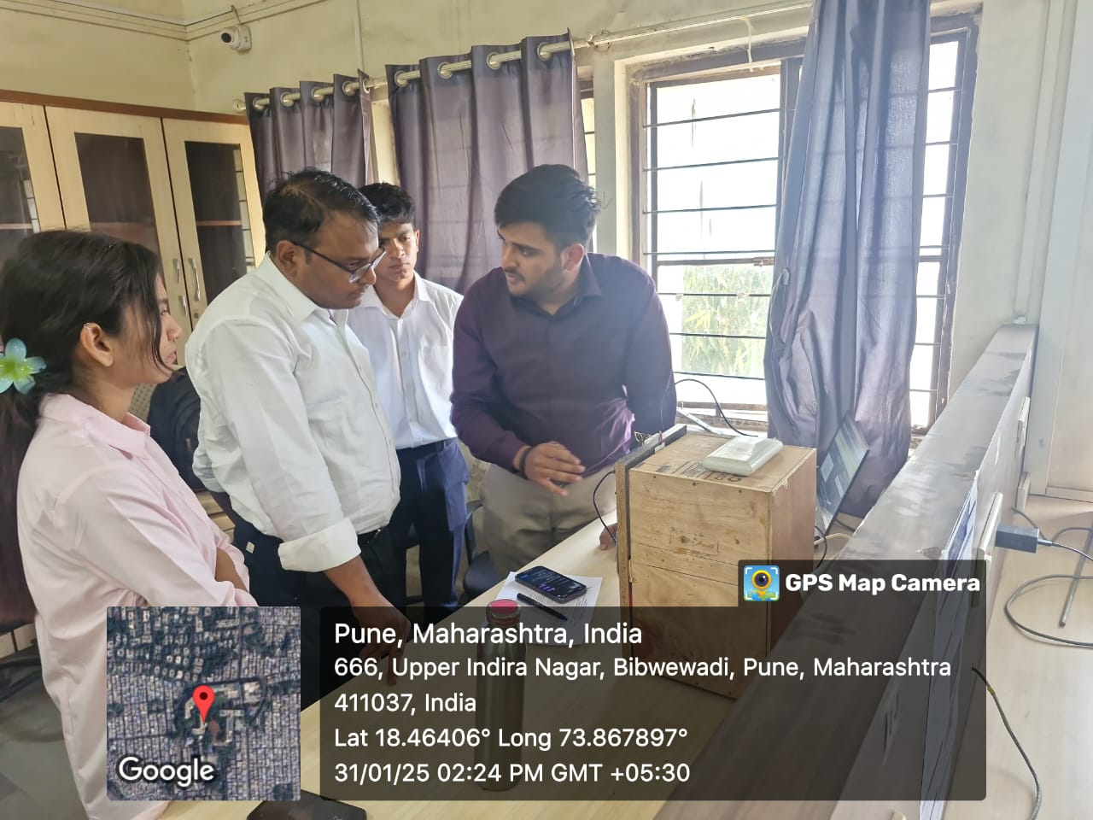

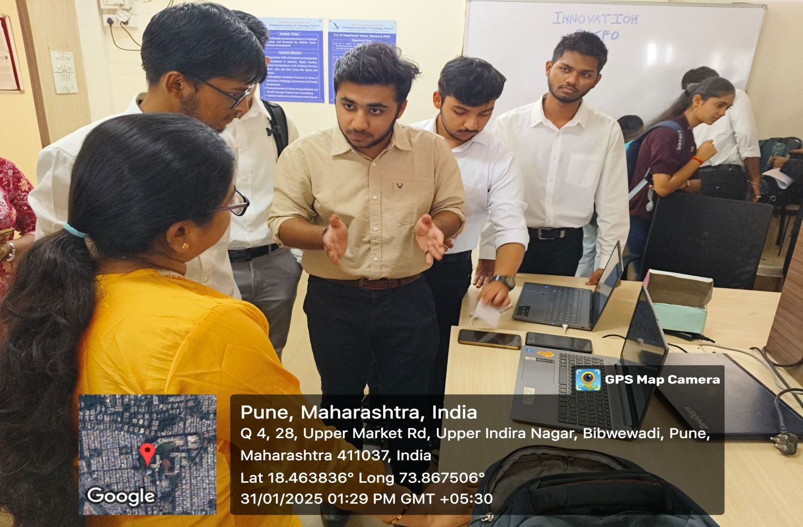

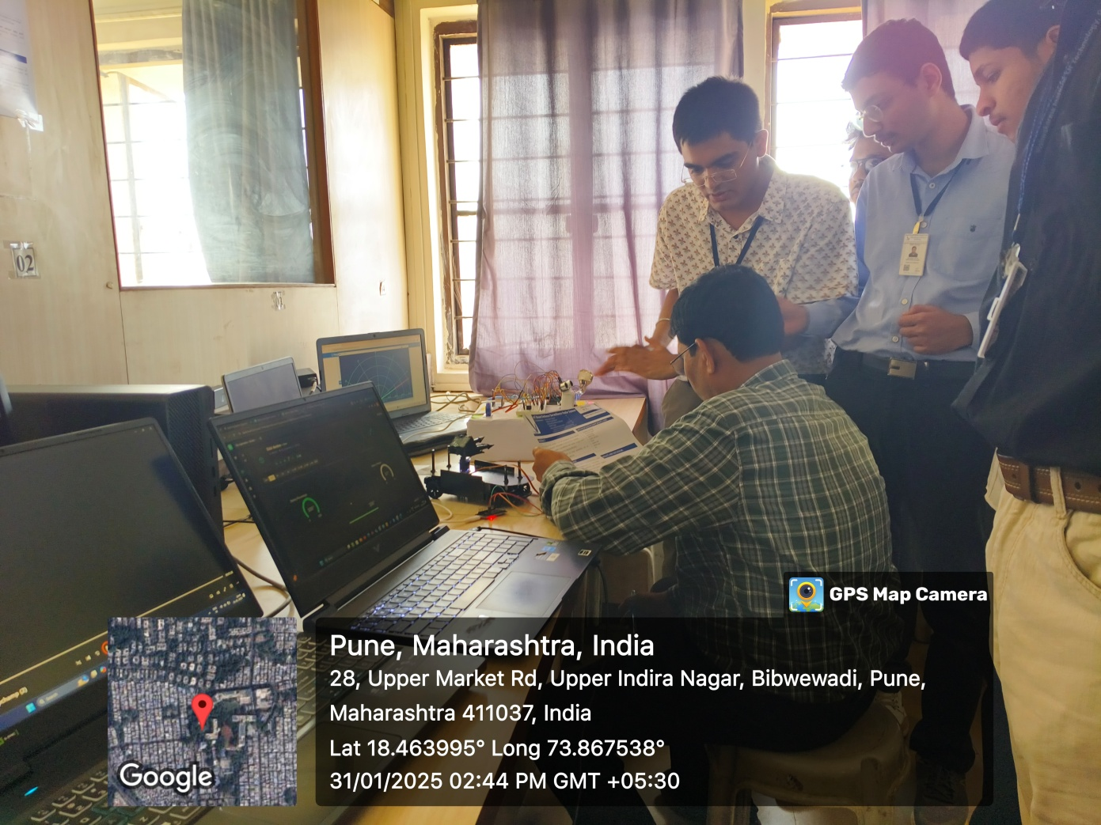

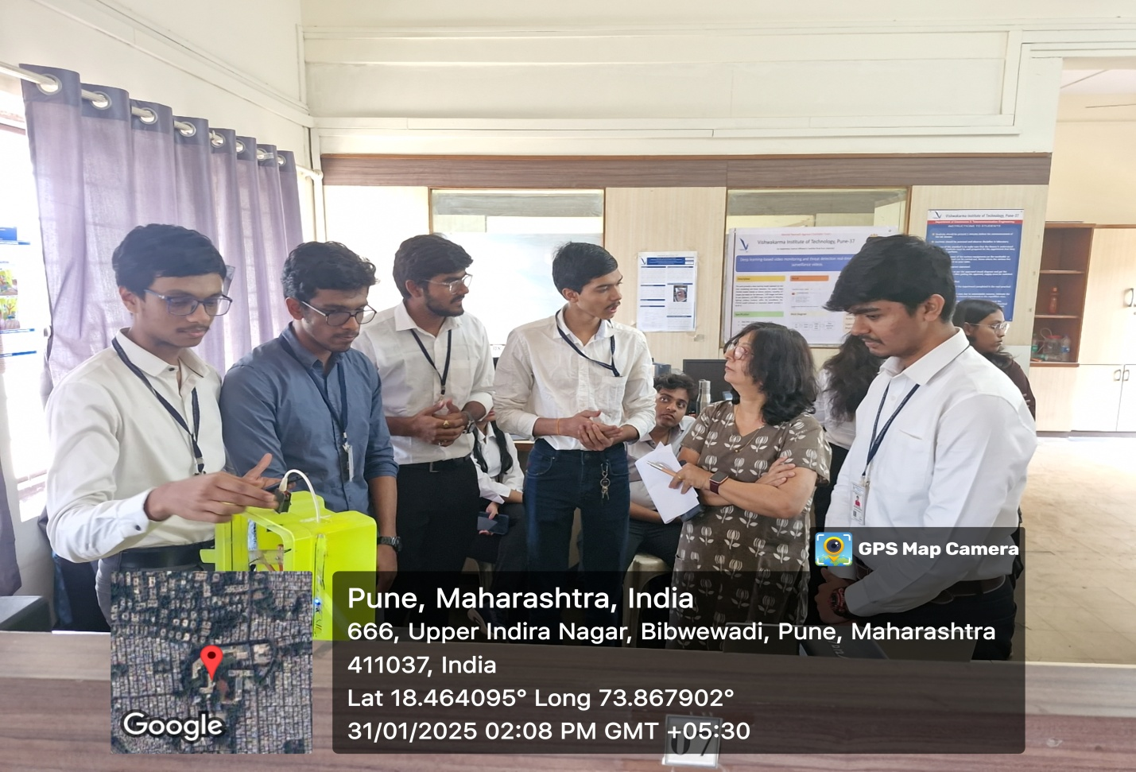

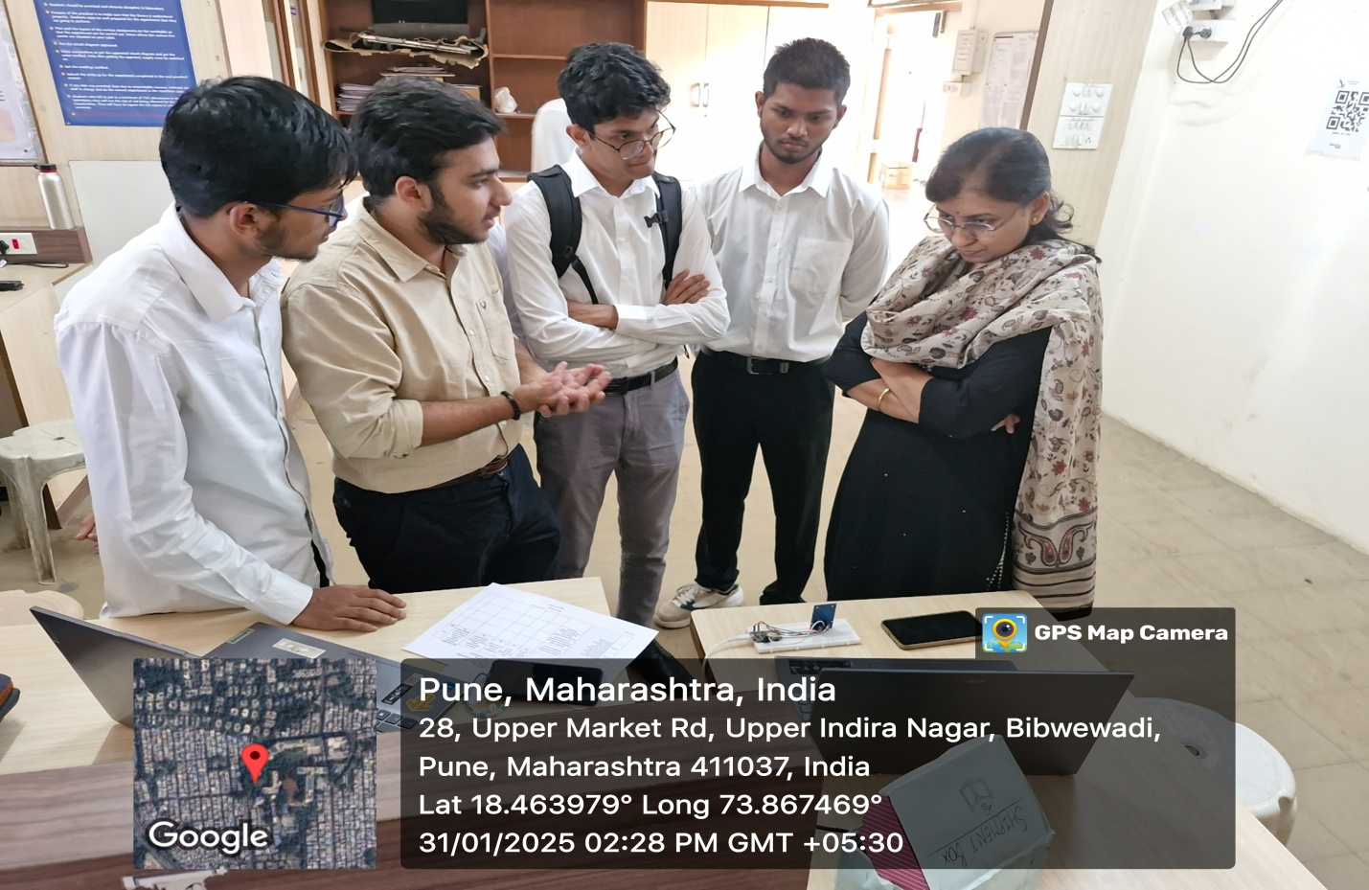

Faculty and large number of students visited the INNOVATION EXPO-2025.

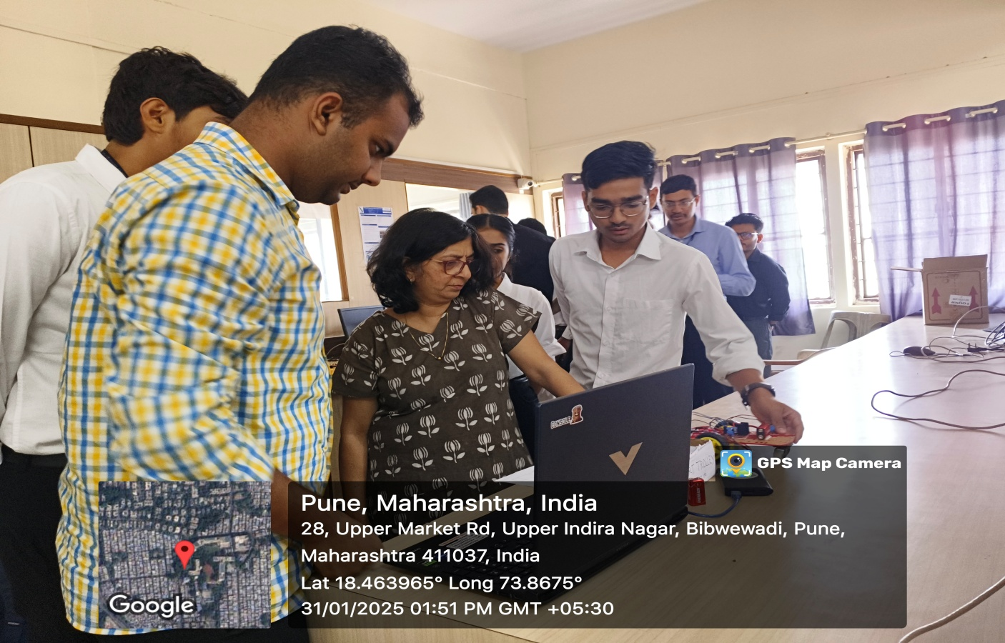

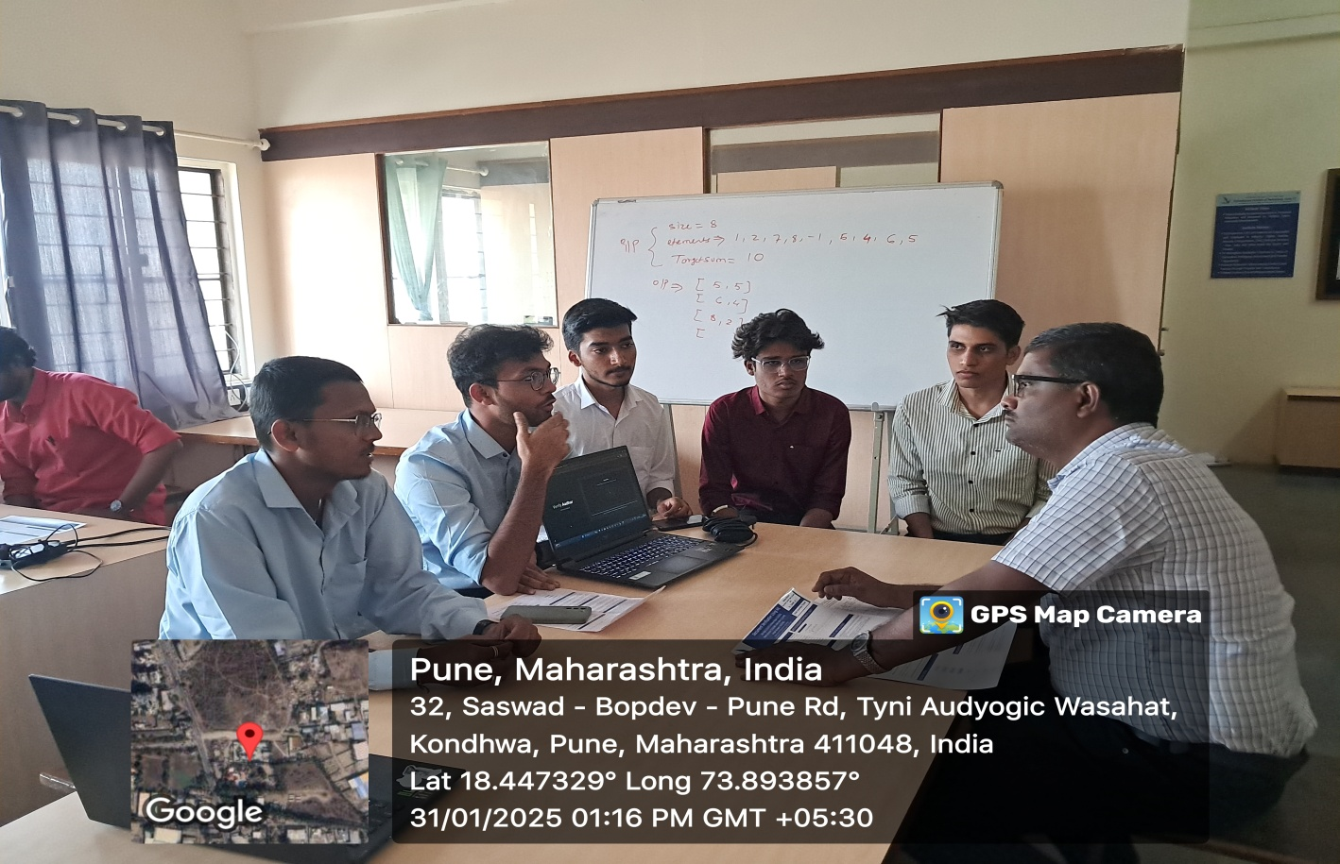

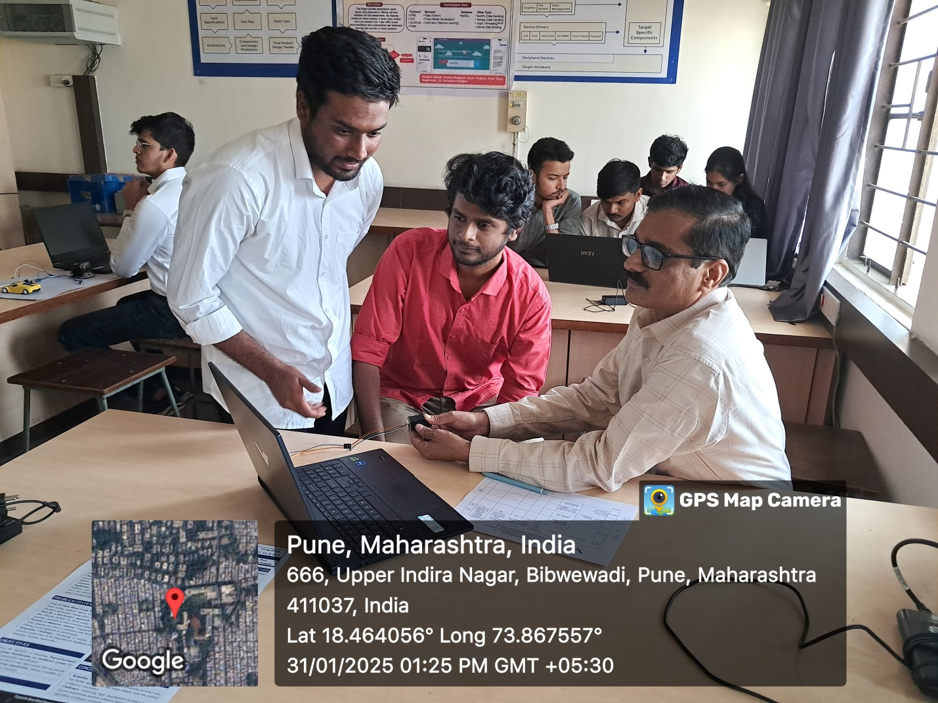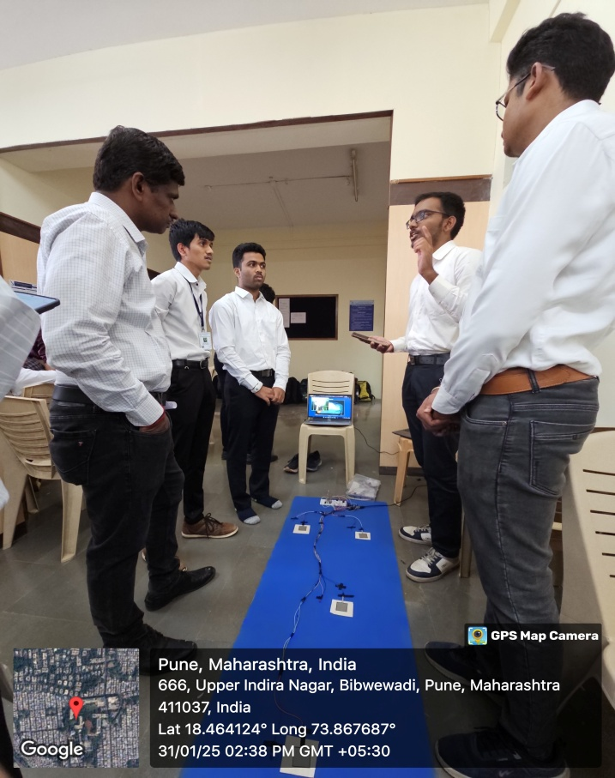 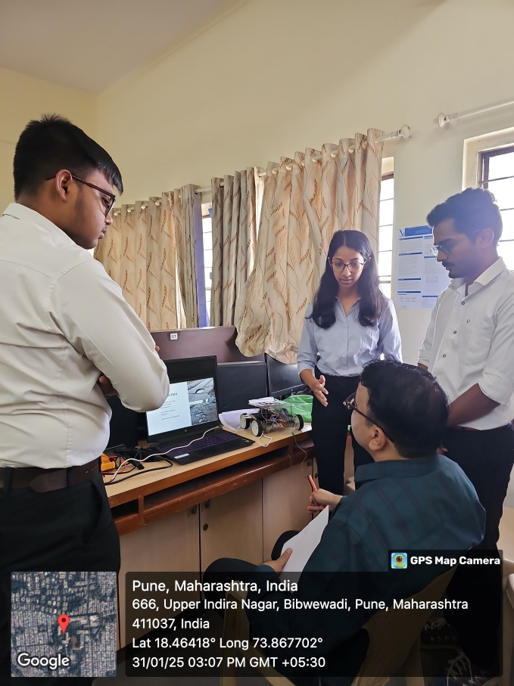

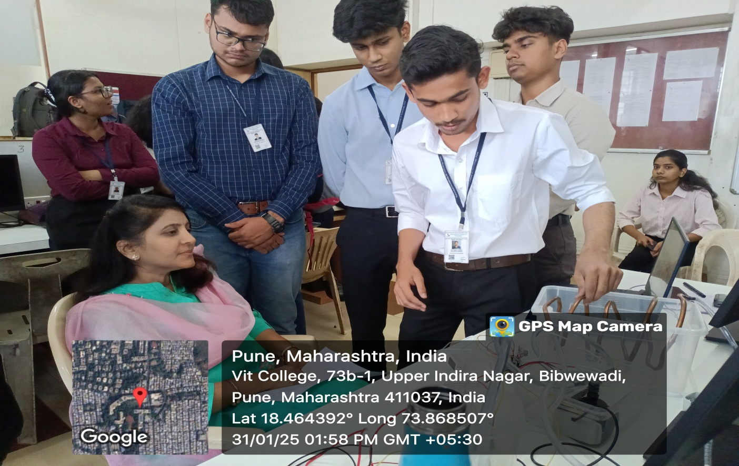

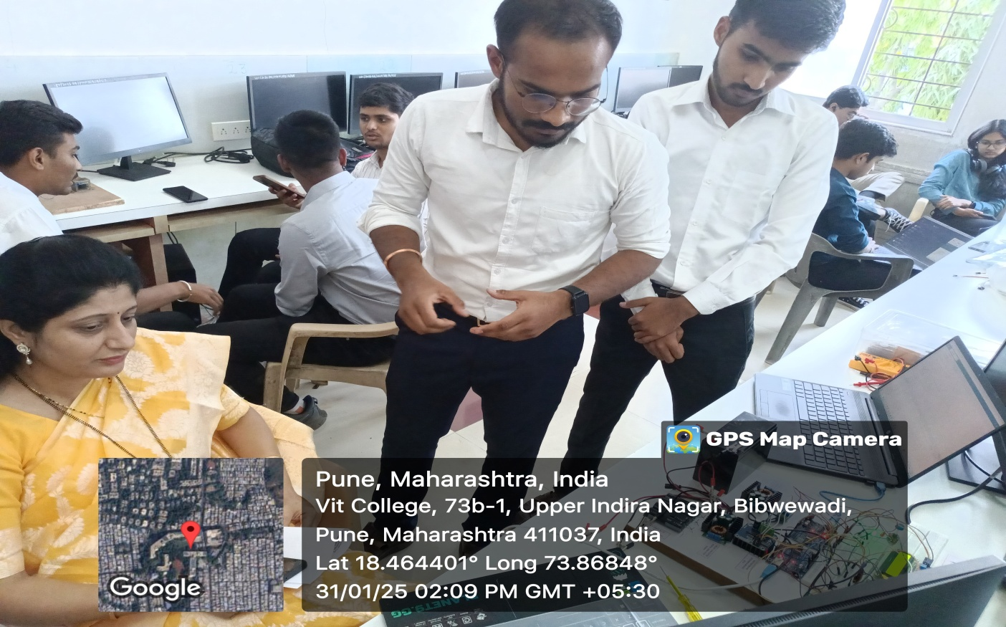

The exhibition witnessed a total active participation of 150 SY-DOME students through 30 projects. The current batch CR-ACR team from the department of multidisciplinary engineering actively participated in coordinating the entire activity under the guidance of Head, Dr S. M. Lambor. All the projects exhibited were best in their own batch; top 03 projects were ranked by the expert. Due to the quality of exhibited projects, 03 additional projects for consolation prizes were also selected.

EDI INNOVATION EXPO-2025-1 Prize Distribution Ceremony was organized on 11th March 2025 at 11:30 AM . The prize distribution ceremony for the EDI innovation Expo 2025, an EDI based project competition held by DOME for the consecutive 4th Semester and successfully organized. The winners were awarded the prizes by honorable Director Dr. Rajesh Jainekar.

**Winners INNOVATION EXPO-2025-1**

|  |  |  |  |  |
| --- | --- | --- | --- | --- |
| **Winner Rank** | **Name of the student** | **Class/Div** | **Project Title** | **Guide Name** |
| **1** | Vikram Jirgale | **CS AIML A** | Retrofitting Approach for Predictive Maintenance | DR. (SMT.) MANISHA RAJESH MHETRE |
| Raj Kakade |
| Prajwal Kadam |
| Atharva Kangralkar |
| **2** | Atharv Chougule | **ET A** | Hexabot | PROF. SUHAS BALKRISHNA BHISE |
| Sarthak Deshmukh |
| Harshavardhan Desai |
| Shreyas Dambalkar |
| **3** | Yash Ambodekar, | **AI&DS A** | Effect of Agnihotra on Life Satisfaction | Prof. (DR.) RAJESH JAGDISH DHAKE |
| Soham Ambar |
| Vivek Agrawal |
| Aarya Lomte |
| **Consolation** | Soham Kanhe | **CS B** | Smart Scarecrow System using IOT and ML | PROF. (DR.) VIJAY DATTATRAY GAIKWAD |
| Sujal Kandgave |
| Krish Kawrani |
| Shravan Katore |
| Parth Kaware |
| **Consolation** | Anurag Deshmukh | **CS AI A** | Automatic road monitoring system | PROF. DNYANESH GAJANAN KANADE |
| Aarya Deshpande |
| Shubham Devkar |
| Kalpesh Devre |
| Anisha Gondhaleka |
| **Consolation** | Nevan Dgama | **ME A** | Vegidry : A portable dehydrator for small scale farmers | PROF. (Dr.) SHILPA MEENOR LAMBOR |
| Krishna Endela |
| Bhumika Divate |
| Prem Deore |
| Rohit Dane |
|  |  |  |  |  |

**Glimpses of Prize Distribution**

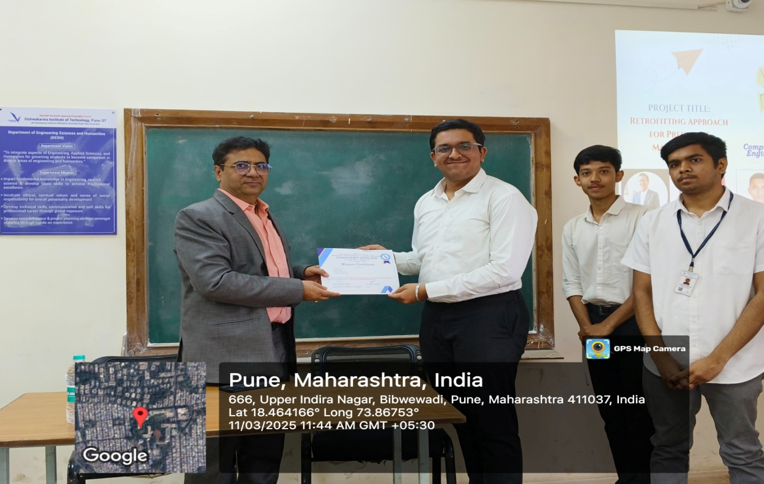 **Winner: Retrofitting Approach for Predictive Maintenance**

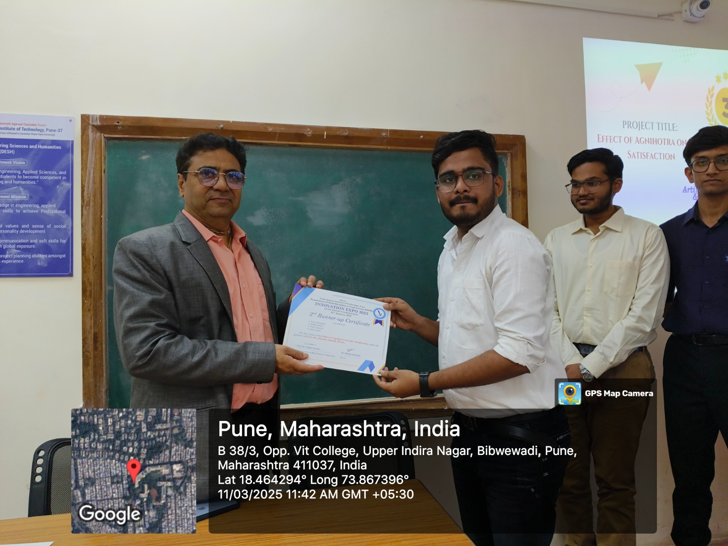

**Second Runner Up : Effect of Agnihotra on Life Satisfaction**

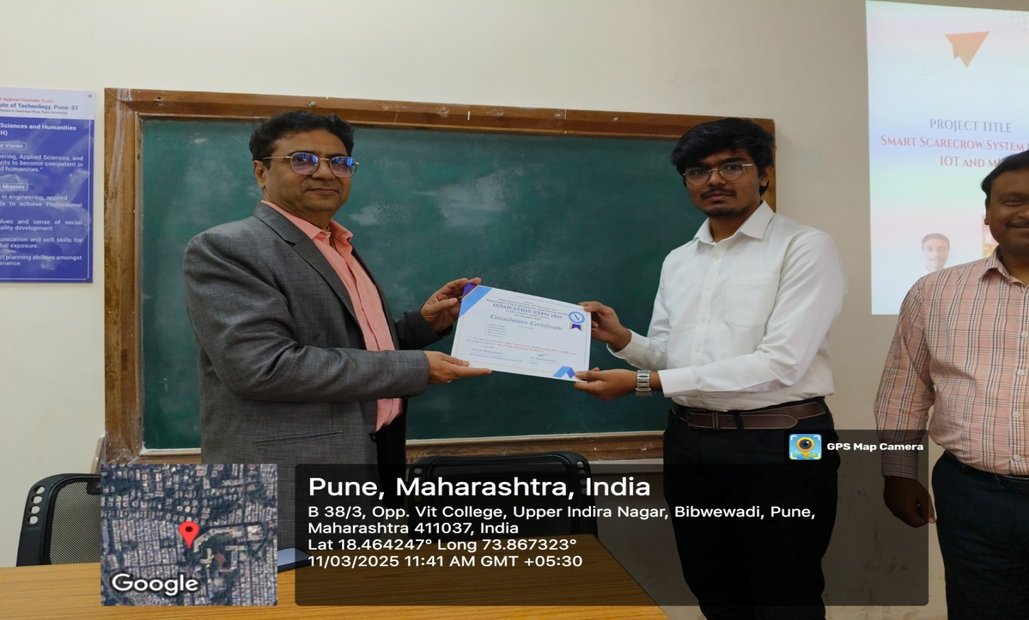

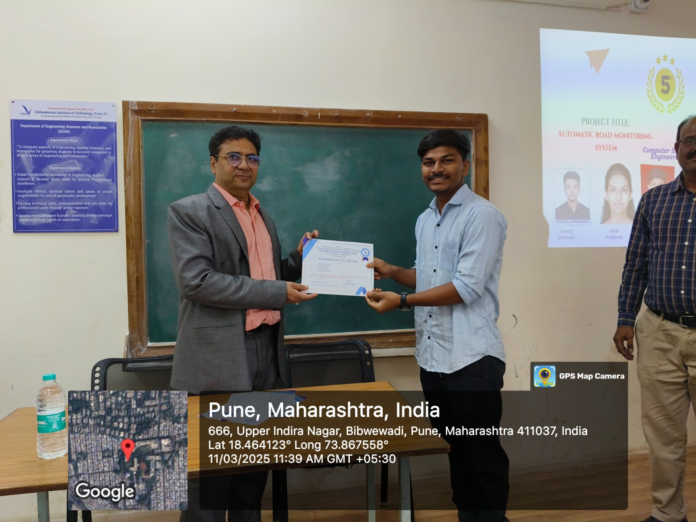

Prof. (Dr.) Rajesh M. Jalnekar Director, Vishwakarma Institute of Technology addressed the Multidisciplinary Engineering students during the prize distribution ceremony, recognizing their innovative efforts and achievements. The event was attended by faculty members and students, celebrating the outstanding projects completed by the students in semester I ,2024-25.

The Director congratulated the students who had excelled in their projects, acknowledged their hard work, creativity, and commitment. He emphasized the importance of hands-on learning and how these projects serve as a bridge between academic knowledge and practical application. The Director highlighted how the projects showcased the students' ability to think outside the box and develop solutions to real-world problems.He also explained the role of AI in the coming years, the steps a student should take while selecting a problem statement and how to develop themselves to susteain in the upcoming AI world.

EDI INNOVATION EXPO-2025-1 Prize Distribution Ceremony supported and attended by Prof.(Dr) S. M. Lambor, Prof.(Dr) S V Kurundkar, Prof.(Dr) Rajesh Dhake, Prof.(Dr) Milind Rane, Prof.(Dr) Dr. N. S. Kulkarni, Prof.R. S. Suryawanshi, Prof.Dnyaneshwar Kanade, Professor. Bhise, Dr. Milind Rane, Dr. Vijay Gaikwad. Dr. Mhetre

**Outcomes: INNOVATION EXPO-2025**

1. The event helped each project team to give an exposure to their ideas so that they can understand the drawbacks in their ideas and can overcome that in next project.
2. Judges gave their valuable suggestions for the betterment of each project and guided them on how they can convert their project into a product so that it becomes ready to face the competition in the market. Judges also expressed interest to mentor some of the ideas personally.
3. Overall, the event nurtured the student’s potential and gave all the participants a platform to showcase their innovative ideas & projects and improve further to achieve heights of success in this competitive world.

**Acknowledgment**

The event **INNOVATION EXPO-2025** was made successful through the efforts and valuable inputs from the Institute and faculties. We would like to extend our heartfelt acknowledgment and appreciation to everyone for making this event memorable.

We are thankful to Prof. (Dr.) Rajesh Jalnekar, Director, Vishwakarma Institute of Technology who has constantly motivated and supported us to conduct various events and inculcate knowledge amongst the students. We also acknowledge Prof. (Dr) Sangita Kurundkar, Asst.Head- Research & Development ,Department of Multidisciplinary Engineering for guiding us to organize such events. We also appreciate the efforts taken by the hardworking organizing faculty and CR-ACR team of DOME.

**Our organizing Team**

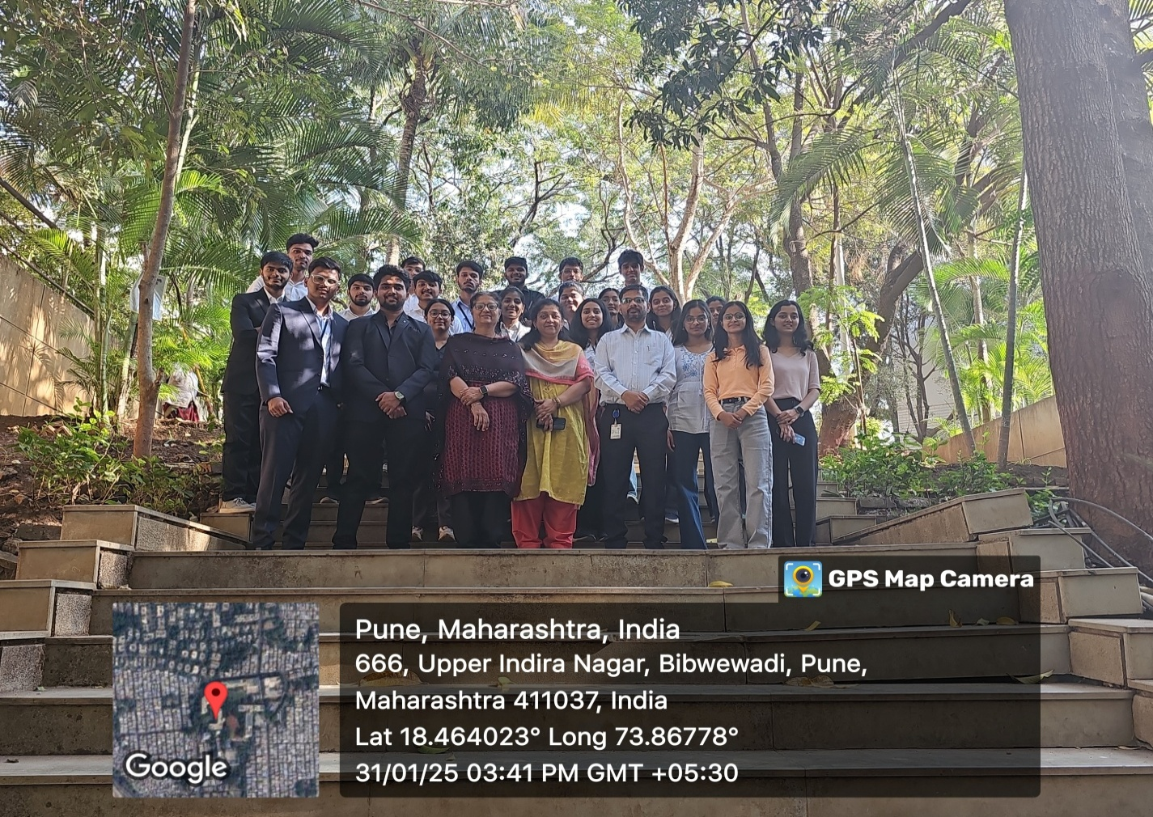

**Dr.Ranjeetsingh Suryawanshi Dr Sangita Kurundkar Dr. Shilpa Lambor**

**EDI Coordinator Asst. Head R&D Head , DOME**