# 1. Induction Program

Date: 20th August

Event: Introductory Induction Program for 1st Year Students

Participants: 500+

Overview:

The Induction Program was held on 20th August to welcome and introduce the 1st year students to ISA VIT Pune. The event saw an impressive turnout of over 500 students. During the program, students were briefed about the association, its objectives, and the various opportunities available for them through ISA. It was a well-organized event aimed at helping new students transition smoothly into the college environment and get them excited about the automation and control domain.

Highlights:

* Welcome speech by the President of ISA VIT Pune.
* Introduction to the benefits of ISA membership.
* Overview of upcoming events and programs.
* Interactive Q&A session to address student queries.

# 2. Industry Visit to the Automation EXPO

Date: 22nd August

Event: Visit to the International Automation EXPO

Participants: 30+

Overview:

On 22nd August, a group of 30+ students from ISA VIT Pune visited the International Automation EXPO. This visit provided students with firsthand exposure to the latest advancements and innovations in the field of automation. They interacted with industry experts, observed cutting-edge technologies, and attended informative sessions on various automation topics.

Highlights:

* Guided tour of the expo showcasing various automation technologies.
* Networking opportunities with industry professionals.
* Insightful sessions and demonstrations by leading automation companies.
* Enhanced understanding of real-world applications of automation.

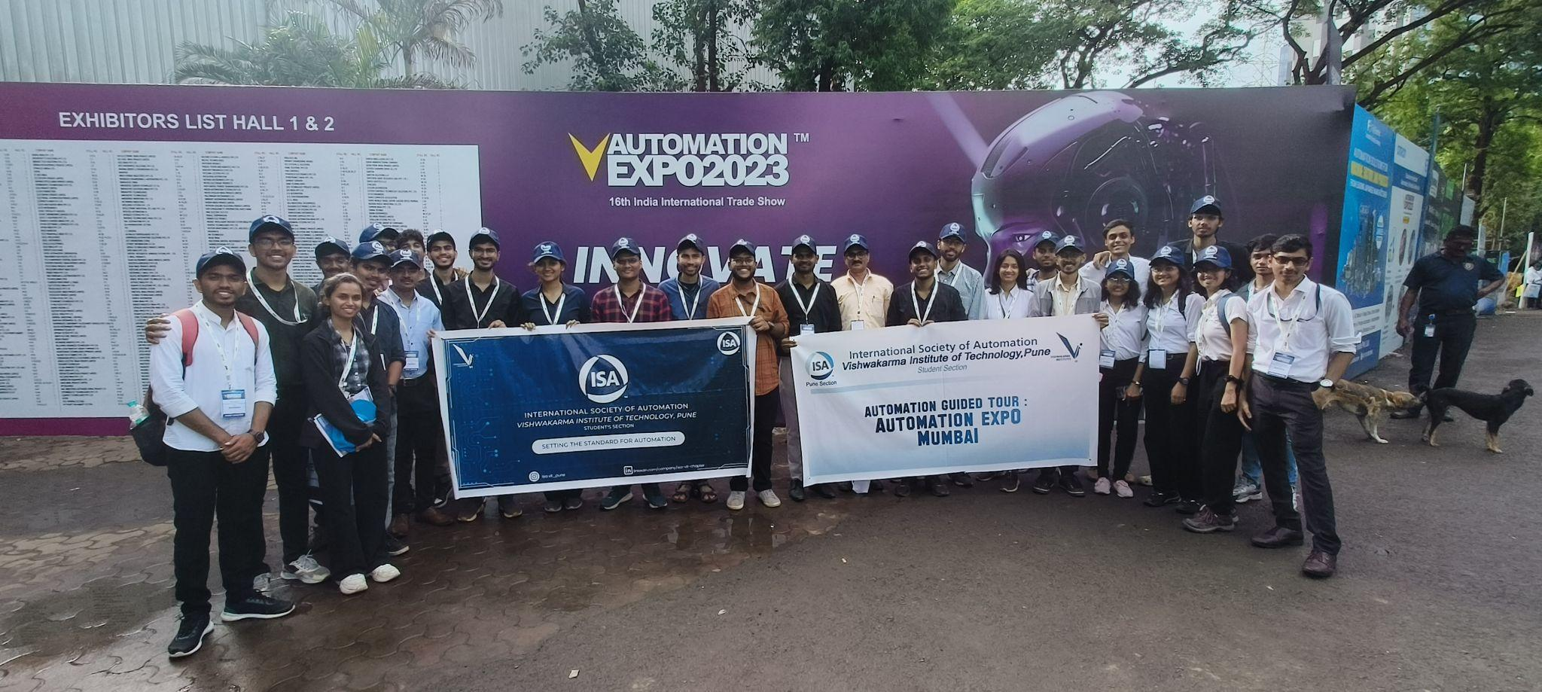

# 3. Automation Nexus

Date: 2nd September

Event: 5-Day Workshop on Introduction to Automation

Participants: 30

Overview:

The Automation Nexus, held from 2nd September, was a comprehensive 5-day workshop aimed at introducing students to the basics of automation. With 30 participants, the workshop covered various aspects of automation, including theoretical knowledge and practical applications. It provided a solid foundation for students interested in pursuing careers in automation.

Highlights:

* Detailed sessions on automation principles and technologies.
* Hands-on projects to apply theoretical knowledge.
* Guest lectures by industry experts.
* Certification of completion for all participants.

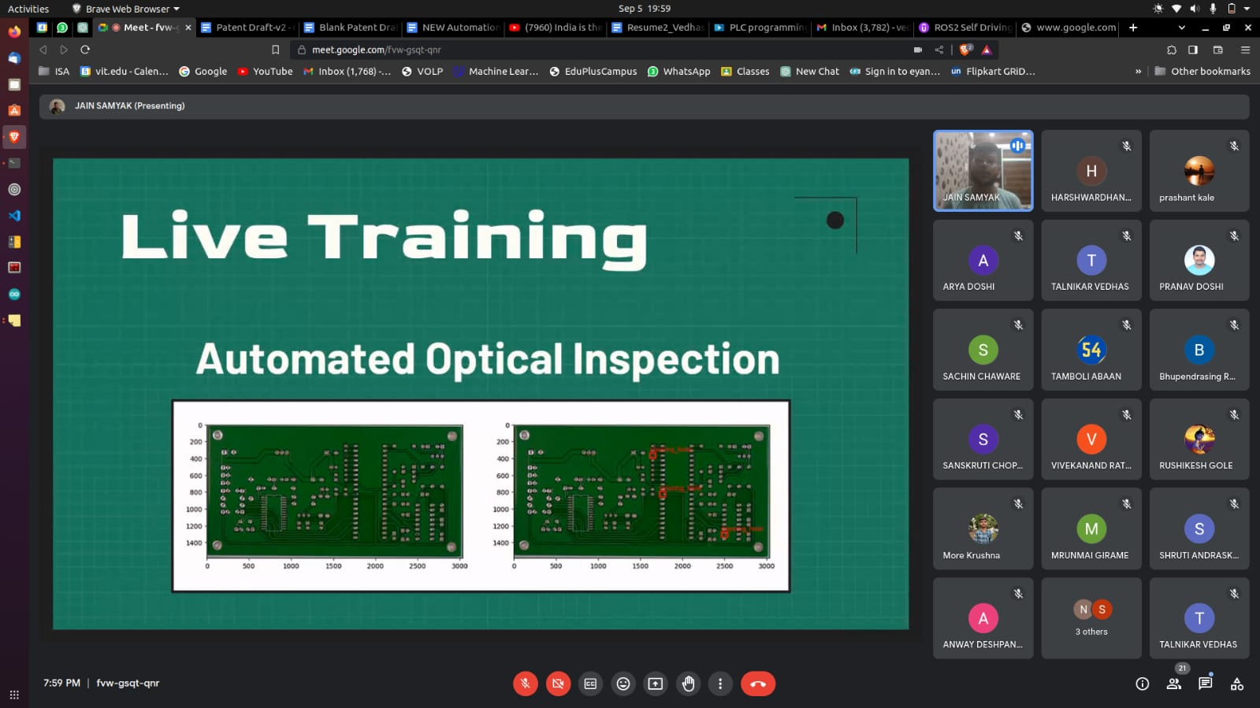

# 4. Competition: Automation Games

Date: 7th September

Event: Participation in Automation Games

Participants: 6

Overview:

On 7th September, two teams from VIT Pune participated in the Automation Games competition. The event was a competitive platform where students showcased their automation skills. Krushna More from VIT Pune won the 2nd runner-up prize, highlighting the talent and preparedness of our students in this field.

Highlights:

* Participation by two skilled teams from VIT Pune.
* Competitive events testing automation knowledge and skills.
* Achievement of 2nd runner-up prize by Krushna More.
* Encouragement for students to engage in more such competitions.

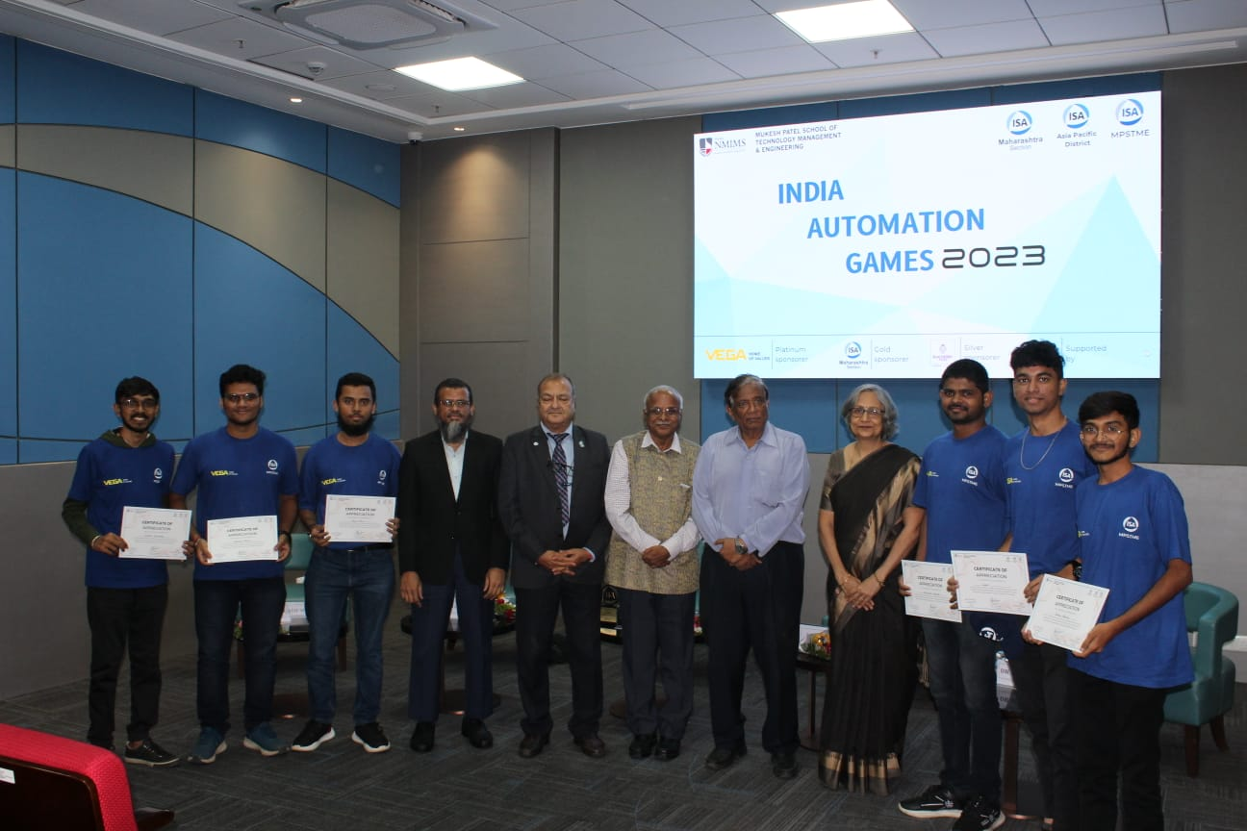

# 5. ROS Training Program

Date: 23rd December

Event: ROS Training Program for ISA Team Members

Participants: 40

Overview:

The ROS Training Program conducted on 23rd December was specifically designed for ISA team members. With 40 participants, the program focused on the Robot Operating System (ROS), providing in-depth training on its applications and functionalities. This training aimed to enhance the technical capabilities of the ISA team, preparing them for advanced projects in robotics and automation.

Highlights:

* Comprehensive training sessions on ROS.
* Practical exercises and real-world applications.
* Improved technical skills of ISA team members.
* Foundation for future projects and innovations in robotics.

Each of these events contributed significantly to the growth and development of the students and the ISA VIT Pune community. They provided valuable learning experiences, networking opportunities, and practical knowledge, aligning with the mission of ISA to foster a deeper understanding and advancement in the field of automation and control.

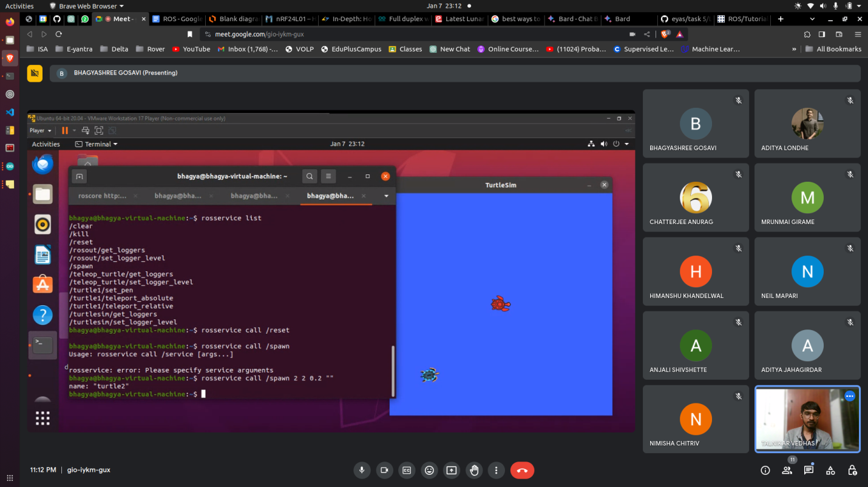

# 6. Ingenious 2024 Competition

Ingenious 2024, organized by ISA VIT Pune, was a groundbreaking initiative aimed at connecting young minds with industry for innovation. The competition provided a platform for students to collaborate with industry leaders, tackle real-world problems, and get rewarded for their brilliance.

Stages of the Competition

Stage 1: Call for Action

* Registration Open: March 1 (FREE!)
* Task Distribution: Participants were given challenging tasks to dive into.
* Proof of Concept: Participants showcased their innovative solutions.
* Product Development Training Session: A comprehensive session was conducted to sharpen participants' skills.

Stage 2: Battle of Builds

* Implementation Period: A 20-day period was allotted for creativity and execution.
* Showcase of Task Execution: Participants displayed their skills and solutions.
* Industry Mentors' Evaluation: Top teams were selected by industry mentors.
* Selection for Industry-Sponsored Project: Selected candidates/teams were given the opportunity to work on an industry-sponsored project.

Stage 3: Project Zenith

* Product Development: Participants engaged in building, experimenting, and testing with development costs sponsored by the company.
* Intense Product Development: A 2-month period for in-depth development.
* Internship Opportunities: Participants were offered summer and full-time internships.

Conclusion

Ingenious 2024 successfully brought together the brightest young talents and industry leaders, fostering a culture of innovation and practical problem-solving. The competition not only provided participants with invaluable experiences and opportunities but also paved the way for future industry collaborations. Participants showcased exceptional dedication and ingenuity, and the event concluded with a promise of continuous support and opportunities for these budding innovators.

ISA VIT Pune is proud of the success of Ingenious 2024 and looks forward to organizing more such initiatives in the future.

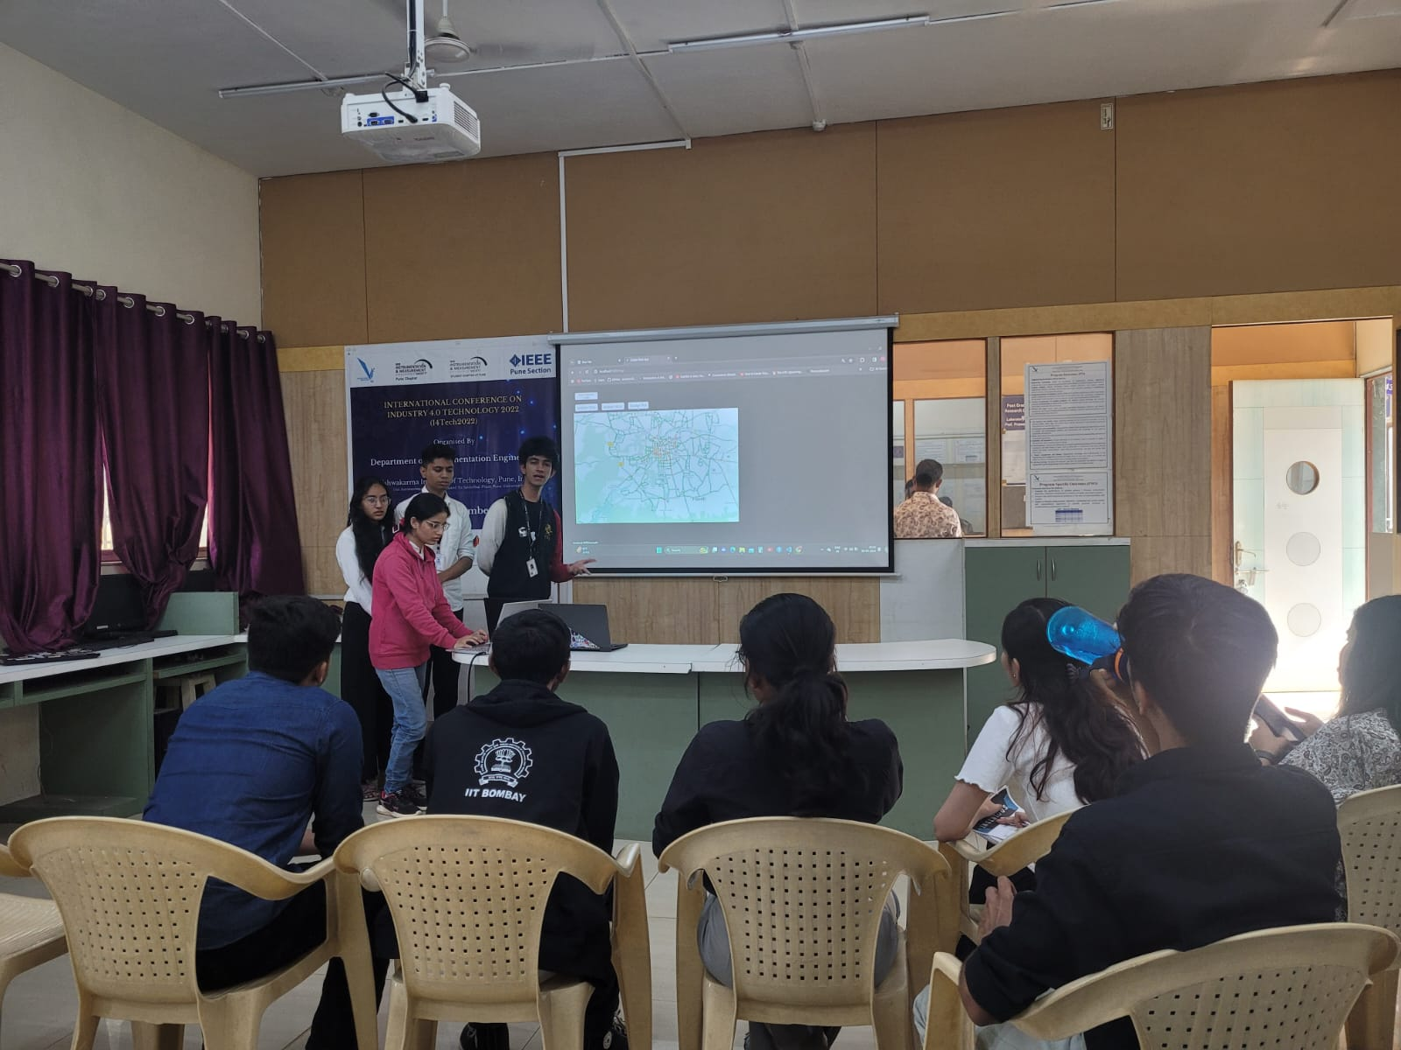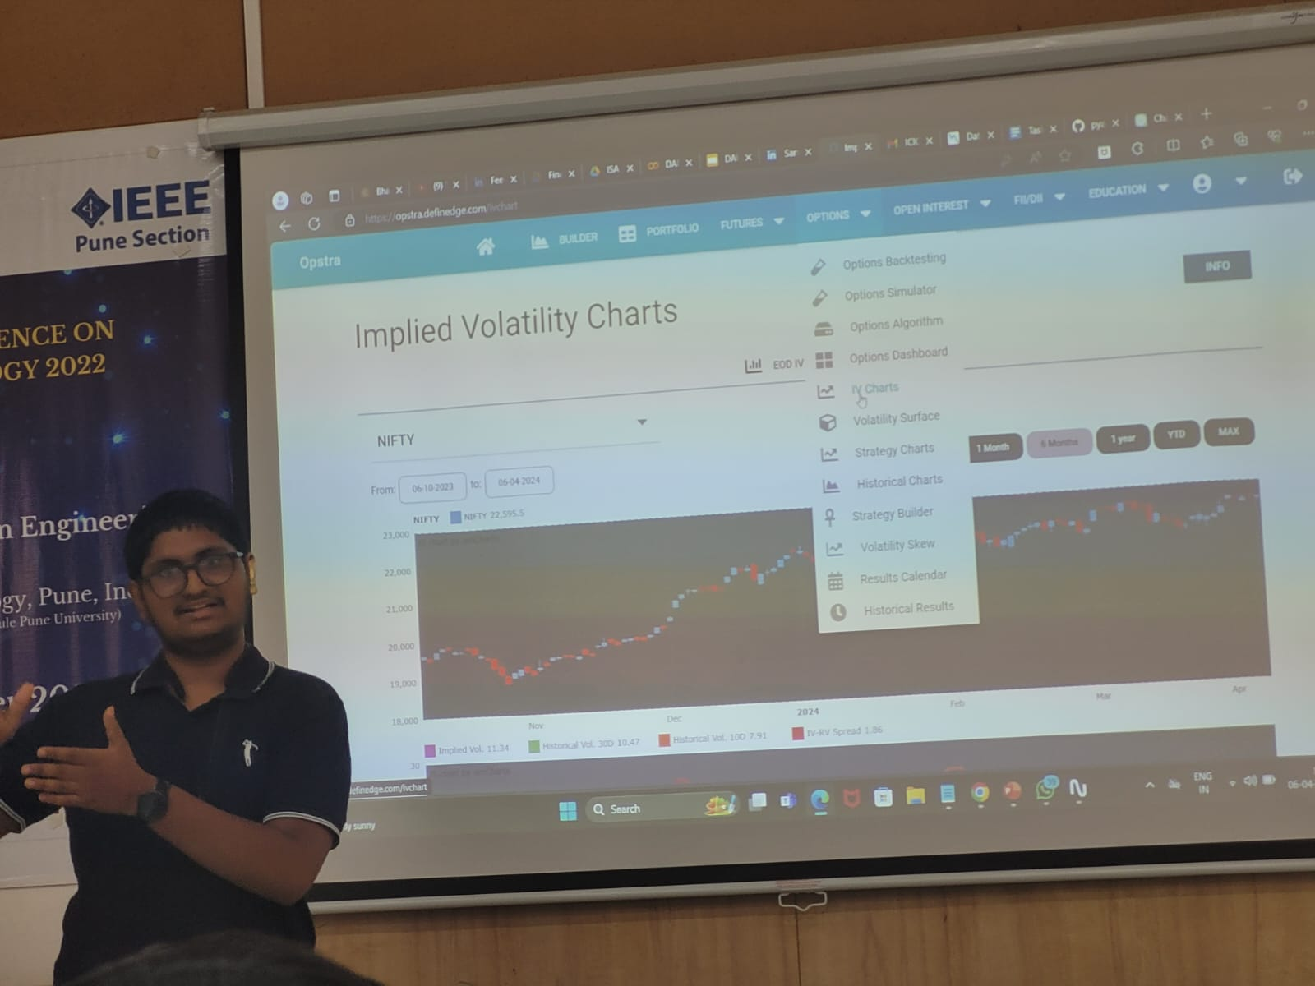

# 7. One Week Online FDP on Industrial Robots

Overview

The Department of Instrumentation Engineering, in collaboration with the International Society of Automation (ISA), Pune Section, successfully organized a One Week Online Faculty Development Program (FDP) on Industrial Robots. The program was held from April 1 to April 5, 2024, from 2:00 pm to 6:00 pm daily via the Zoom platform.

Program Details

Dates: April 1-5, 2024

Time: 2.00 pm to 6.00 pm

Platform: Online on Zoom

Registration Fees: None

Speakers: Eminent speakers from the industry

Hands-on Session: Focused on Robot Operating System (ROS)

Demonstrations: Included Industrial Robot and Delta Robot demonstrations

Highlights

* Eminent Industry Speakers: The FDP featured insightful sessions by distinguished speakers from the industry, who shared their expertise and knowledge on various aspects of industrial robotics.
* Hands-on Session on ROS: A key highlight of the FDP was the practical, hands-on session on Robot Operating System (ROS), providing participants with valuable practical experience and skills.
* Robot Demonstrations: The program included live demonstrations of industrial robots and delta robots, giving participants a real-world perspective on the application and operation of these technologies.
* Engagement and Participation: The program saw enthusiastic participation from faculty members and professionals in the field of instrumentation and automation. The interactive sessions and practical demonstrations ensured a high level of engagement.

Conclusion

The One Week Online FDP on Industrial Robots was a significant success, achieving its objective of enhancing the knowledge and skills of participants in the field of industrial robotics. The collaboration with ISA, Pune Section, and the contribution of eminent speakers from the industry played a crucial role in the program's success. The department is committed to continuing such initiatives to foster learning and development in advanced technological areas.

The Department of Instrumentation Engineering extends its gratitude to all the speakers, participants, and organizers for their contributions to making this FDP a fruitful and enriching experience.

